
Touchstones
Netcards

Emotional Intelligence Netcards with Text

All Directions HRJ
Anger HRJ
Children HRJ
Choose Wisely HRJ

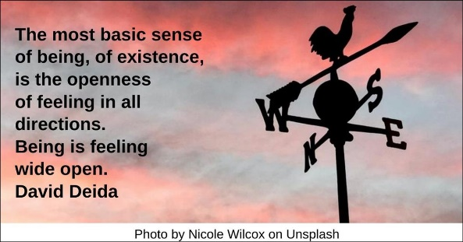

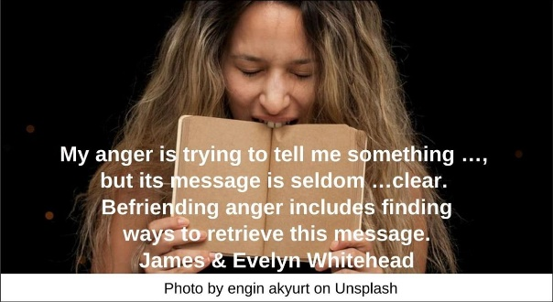

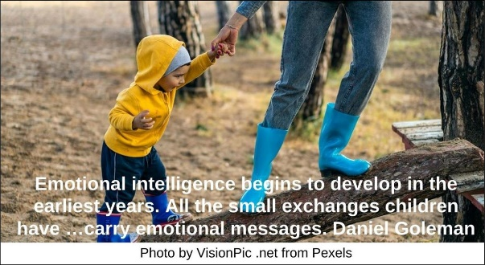

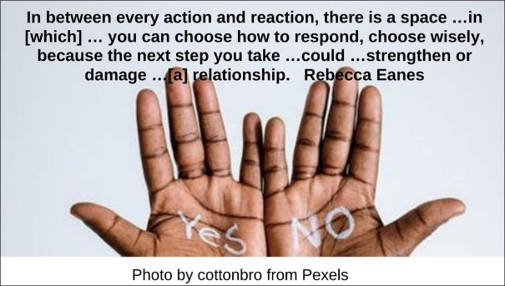

Compassion HRJ
Compassionate Heart HRJ
Despair HRJ
Empathy HRJ



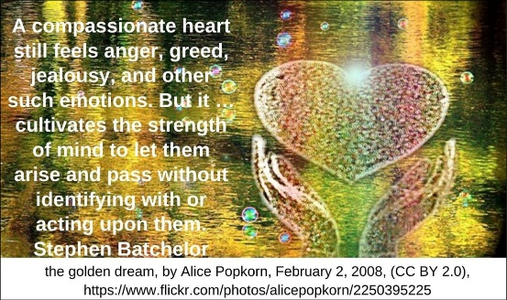

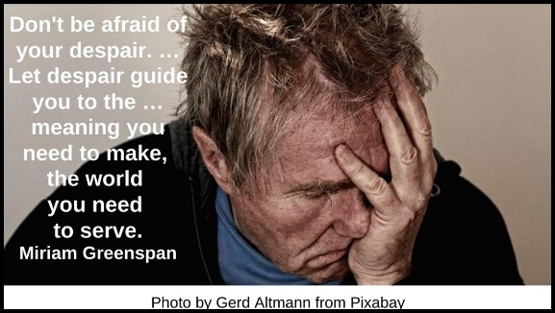

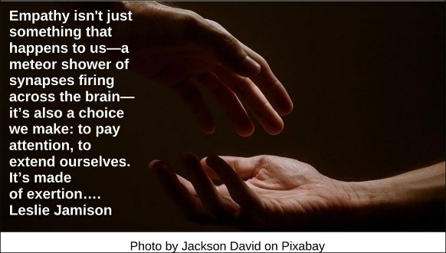

Energy HRJ
EQ HRJ
Everyday Practice HRJ
Generosity HRJ



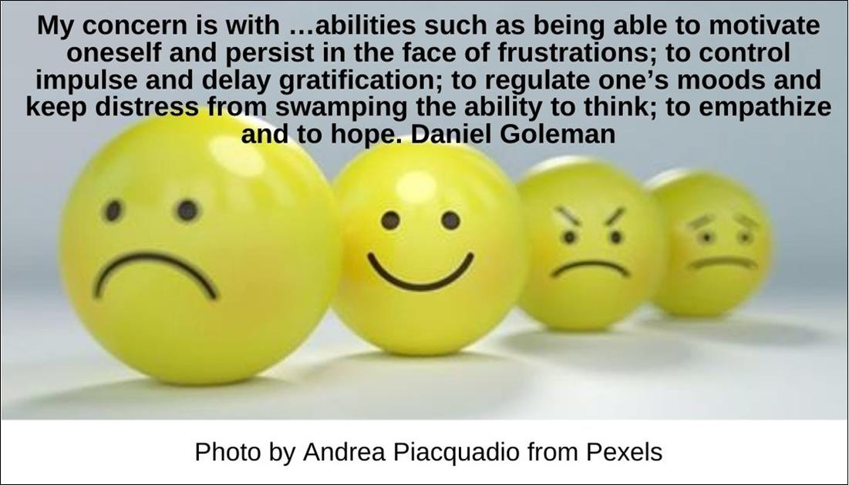

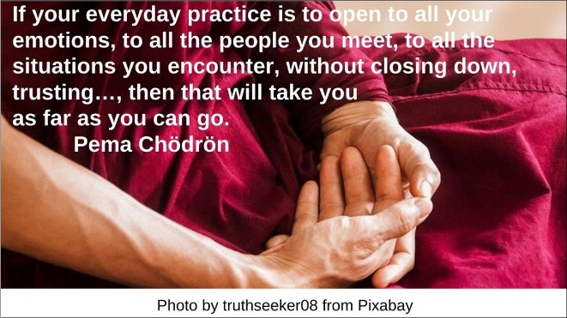

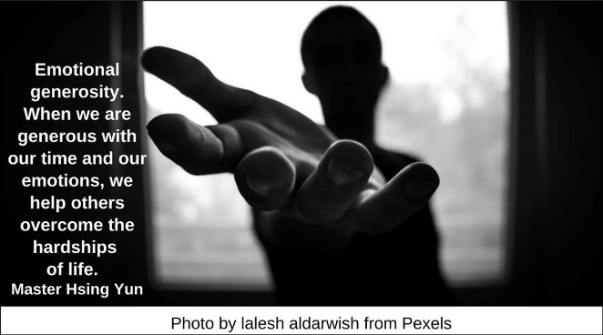

Heart and Mind HRJ
Imagination HRJ
Inquiry HRJ
Juggling HRJ

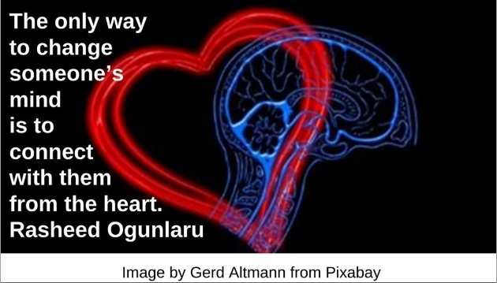

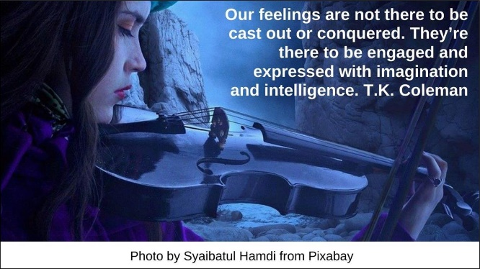

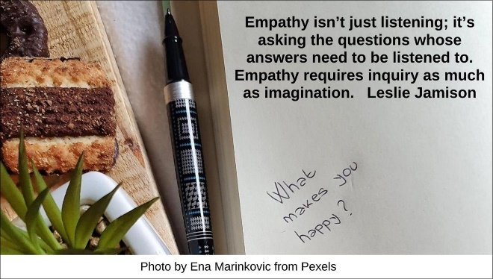

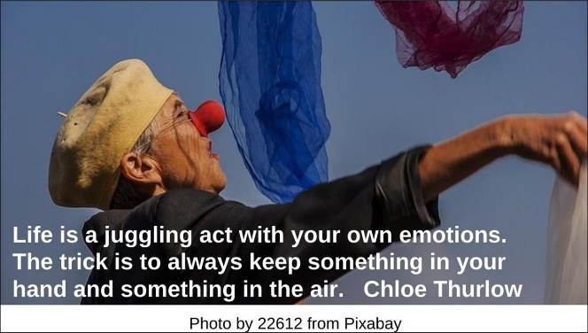

Mother HRJ
Move Out HRJ
Noise HRJ
Pallet HRJ

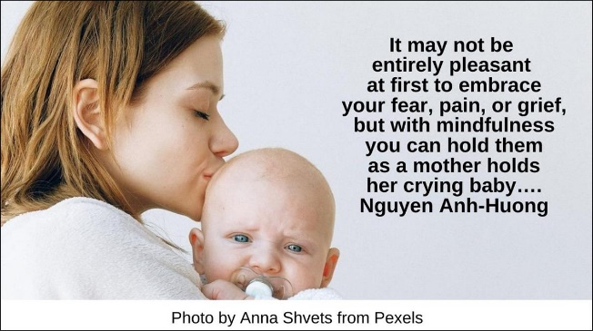

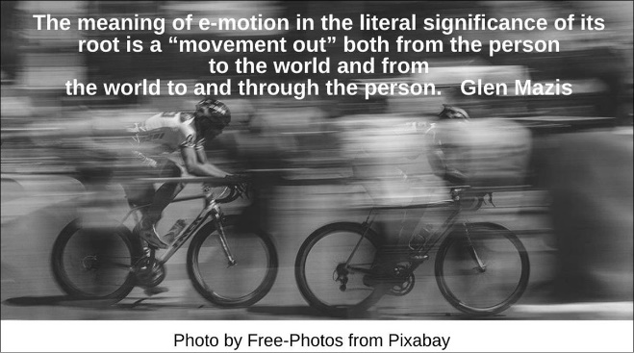

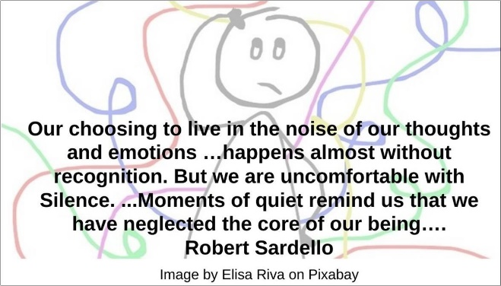

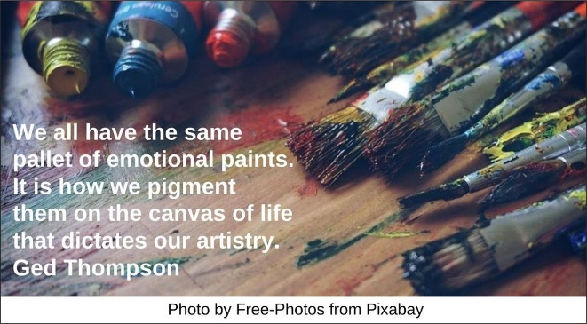

Perception HRJ
Practices HRJ
Respond HRJ
River HRJ

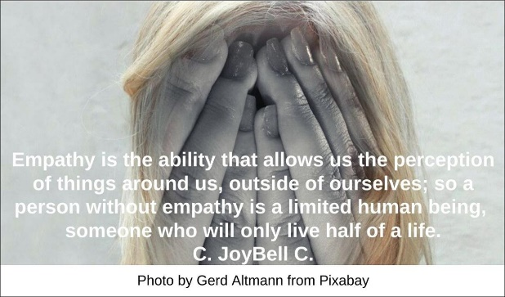

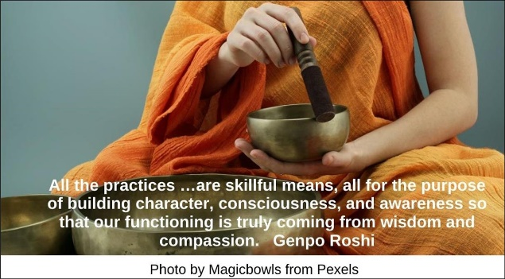

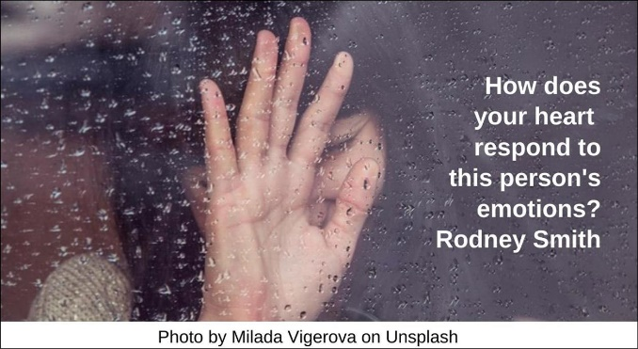

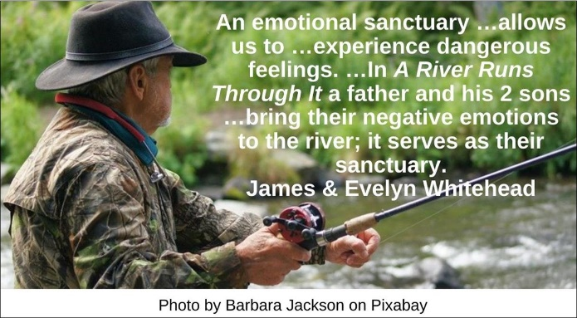

Self-Awareness HRJ
Soft HRJ
Spirituality HRJ
Stop HRJ

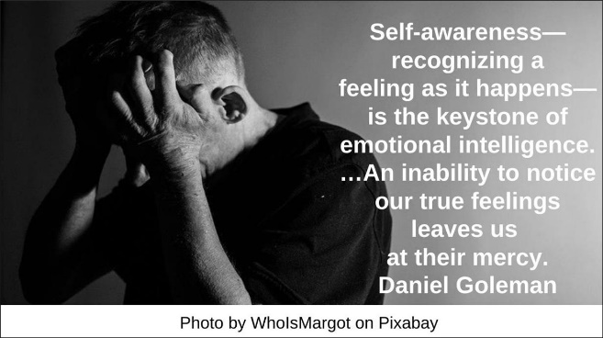

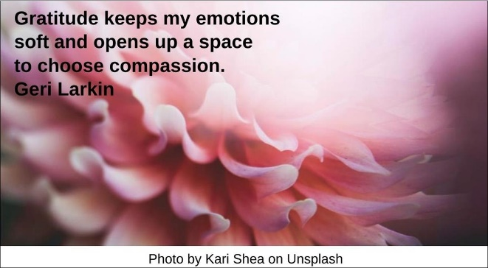

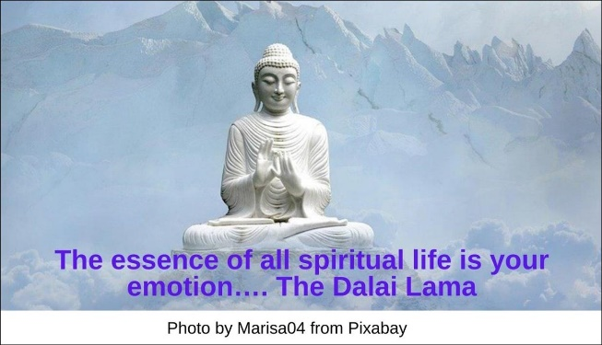

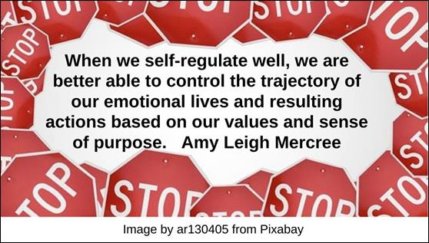

Truth HRJ
Two Minds HRJ
Waves HRJ

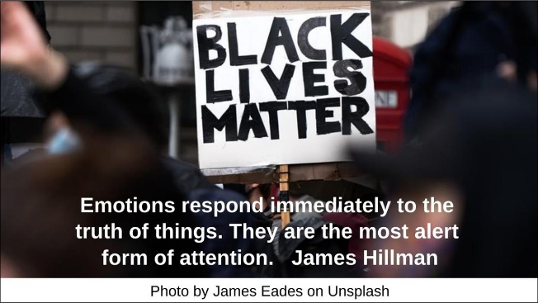

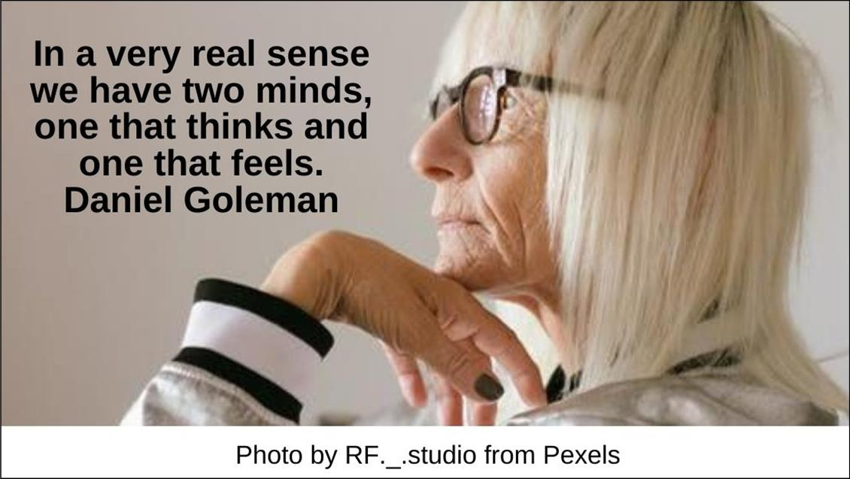

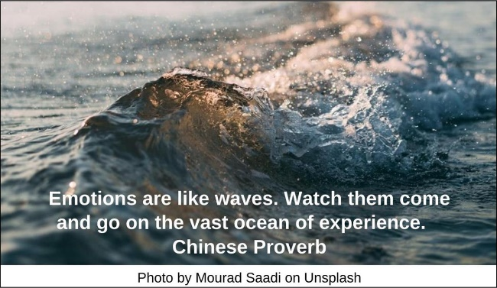

Text of Quotes
All Directions HRJ
The most basic sense of being, of existence, is the openness of feeling in all directions. Being is feeling wide open. David Deida

Anger HRJ
My anger is trying to tell me something …, but its message is seldom …clear. Befriending anger includes finding ways to retrieve this message. James & Evelyn Whitehead

Children HRJ
Emotional intelligence begins to develop in the earliest years. All the small exchanges children have …carry emotional messages. Daniel Goleman

Choose Wisely HRJ
Self-Regulation: In between every action and reaction, there is a space …in [which] … you can choose how to respond, choose wisely, because the next step you take …could …strengthen or damage …[a] relationship. Rebecca Eanes

Compassion HRJ
The passion of so many now is one of pain, of shock, of grieving, and of loss. Compassion allow you to feel those difficult emotions and the pain that lies beneath them. Gary Zukav

Compassionate Heart HRJ
A compassionate heart still feels anger, greed, jealousy, and other such emotions. But it …cultivates the strength of mind to let them arise and pass without identifying with or acting upon them. Stephen Batchelor

Despair HRJ
Don't be afraid of your despair. …Let despair guide you to the …meaning you need to make, the world you need to serve. Miriam Greenspan
Empathy HRJ
Empathy isn't just something that happens to us—a meteor shower of synapses firing across the brain—it’s also a choice we make: to pay attention, to extend ourselves. It’s made of exertion…. Leslie Jamison

Energy HRJ
Emotions are the richest source of energy we possess. Karla McLaren

EQ HRJ
My concern is with …abilities such as being able to motivate oneself and persist in the face of frustrations; to control impulse and delay gratification; to regulate one’s moods and keep distress from swamping the ability to think; to empathize and to hope. Daniel Goleman

Everyday Practice HRJ
If your everyday practice is to open to all your emotions, to all the people you meet, to all the situations you encounter, without closing down, trusting…, then that will take you as far as you can go. Pema Chödrön

Generosity HRJ
Emotional generosity. When we are generous with our time and our emotions, we help others overcome the hardships of life. Master Hsing Yun

Heart and Mind HRJ
The only way to change someone’s mind is to connect with them from the heart. Rasheed Ogunlaru

Imagination HRJ
Our feelings are not there to be cast out or conquered. They’re there to be engaged and expressed with imagination and intelligence. T.K. Coleman

Inquiry HRJ
Empathy isn’t just listening; it’s asking the questions whose answers need to be listened to. Empathy requires inquiry as much as imagination. Leslie Jamison

Juggling HRJ
Life is a juggling act with your own emotions. The trick is to always keep something in your hand and something in the air. Chloe Thurlow

Mother HRJ
It may not be entirely pleasant at first to embrace your fear, pain, or grief, but with mindfulness you can hold them as a mother holds her crying baby…. Nguyen Anh-Huong

Move Out HRJ
The meaning of e-motion in the literal significance of its root is a “movement out” both from the person to the world and from the world to and through the person. Glen Mazis

Noise HRJ
Our choosing to live in the noise of our thoughts and emotions …happens almost without recognition. But we are uncomfortable with Silence. …Moments of quiet remind us that we have neglected the core of our being…. Robert Sardello

Pallet HRJ
We all have the same pallet of emotional paints. It is how we pigment them on the canvas of life that dictates our artistry. Ged Thompson

Perception HRJ
Empathy is the ability that allows us the perception of things around us, outside of ourselves; so a person without empathy is a limited human being, someone who will only live half of a life. C. JoyBell C.
Practices HRJ
All the practices …are skillful means, all for the purpose of building character, consciousness, and awareness so that our functioning is truly coming from wisdom and compassion. Genpo Roshi

Respond HRJ
How does your heart respond to this person's emotions? Rodney Smith

River HRJ
An emotional sanctuary …allows us to …experience dangerous feelings. …In A River Runs Through It a father and his 2 sons …bring their negative emotions to the river; it serves as their sanctuary. James & Evelyn Whitehead

Self-Awareness HRJ
Self-awareness—recognizing a feeling as it happens—is the keystone of emotional intelligence. …An inability to notice our true feelings leaves us at their mercy. Daniel Goleman

Soft HRJ
Gratitude keeps my emotions soft and opens up a space to choose compassion. Geri Larkin

Spirituality HRJ
The essence of all spiritual life is your emotion…. The Dalai Lama

Stop HRJ
When we self-regulate well, we are better able to control the trajectory of our emotional lives and resulting actions based on our values and sense of purpose. Amy Leigh Mercree

Truth HRJ
Emotions respond immediately to the truth of things. They are the most alert form of attention. James Hillman
Two Minds HRJ
In a very real sense we have two minds, one that thinks and one that feels. Daniel Goleman

Waves HRJ
Emotions are like waves. Watch them come and go on the vast ocean of experience. Chinese Proverb

